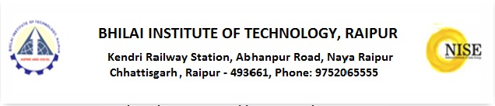
Application form

Affix a passport size photo
SuryaMitra Skill Development Program 2018
- Name of applicant: …………………………………………………………………………
- Father’s Name: ……………………………………………………………………………….
- Mother’s Name: ………………………………………………………………………………
- Date of Birth: ………………………Email id……………………………………………...
- Sex: …………………Category: ……………….Contact No: ………………………….
- Aadhar No. ……………………………………………………………..
- Permanent Address: ………………………………………………………………………………………………………..
…………………………………………………………………………………………………………………………………………
- Present address: ……………………………………………………………………………………………………………..
…………………………………………………………………………………………………………………………………………
- Academic Qualification:
Exam passed | Board/University | Appeared /passed | Year | Secured position with %

Other qualification (if any): …………………………………………………………………………………………

The statement made above and filled in different column are true to the best of my knowledge and belief. I fully understand everything and have personally filled up the columns.

Date: Signature of the students

